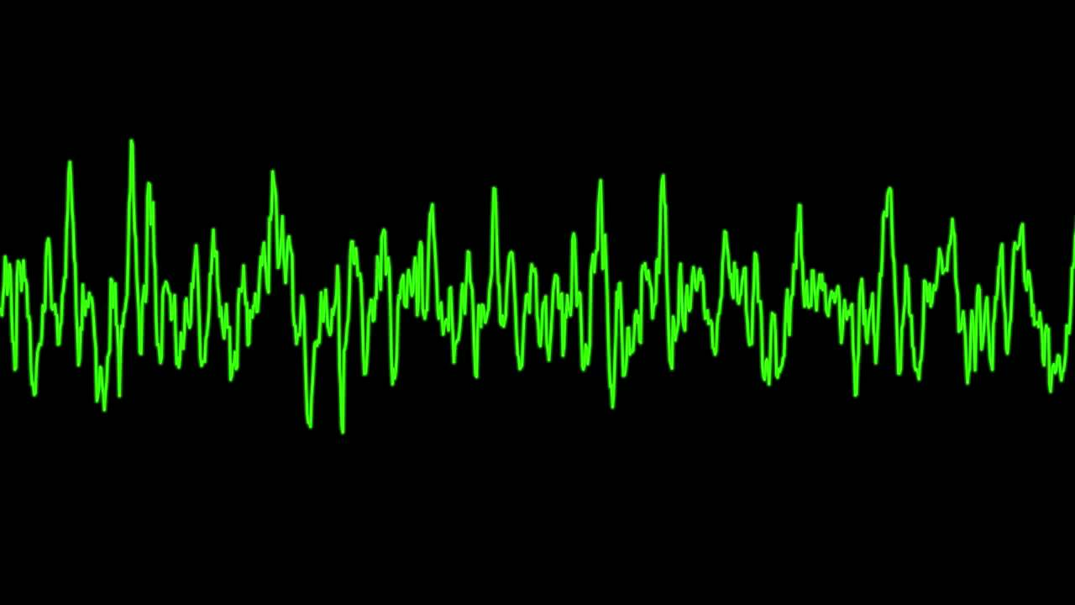

Project 2

Function Genorator

Kyle Rosenthal | CPE 329-05-Gerfen | 4/17/2017 | Spring 2017

# Purpose

The purpose of this project was to develop a better understanding of timers and interrupts, off chip communication through SPI, and digital to analog conversion. Though the designing and building of a waveform generator. In addition the project included though supplemental research, a better understand of pseudo random number generators and how they can be used to simulate noise. The waveform generator parts will also refresh the understanding of getting keypad input as well as setting up a state machine.

## Link to Video

<https://www.youtube.com/watch?v=U7773u7U4y4>

# System Requirements

* System shall have a keypad.
  + The ‘1’ button shall decrease frequency by 100 Hz to a minimum of 100 Hz.
  + The ‘2’ button shall set frequency to 300 Hz.
  + The ‘3’ button shall increase frequency by 100 Hz to a maximum of 500 Hz.
  + The ‘5’ button shall set the waveform mode to noise.
  + The ‘6’ button shall cycle the pulse multiplier between 0 and 9.
  + The ‘7’ button shall set the waveform mode to square wave.
  + The ‘8’ button shall set the waveform mode to sine wave.
  + The ‘9’ button shall set the waveform mode to saw wave.
  + The ‘*’ button shall decrease duty cycle by 10% to a minimum of 10%.
  + The ‘0’ button shall set duty cycle to 50%.
  + The ‘#’ button shall increase duty cycle by 10% to a maximum of 90%.
* System shall have a DAC outputting waveforms as specified by the keypad.
  + The DAC shall output the wave as set by the keypad.
  + The DAC shall adjust frequency as set by the keypad.
  + The DAC shall output pseudo-noise when in noise waveform mode.
  + The DAC shall adjust the duty cycle of the square wave as set by the keypad.
  + The DAC shall pause each delay each cycle of a wave by the period multiplied by the pulse multiplier as set by the keypad.
* Shall operate at 24 MHz

# System Specifications

|  |  |  |
| --- | --- | --- |
| Component | Spec | Value |
| MSP432 | Model | MSP432P401R |
|  | Frequency | 24 MHz |
|  | Interrupts | Enabled |
|  | Input Power | 5 V |
| 4921 SPI DAC | Model | MCP4921 |
|  | V[DD] | 3.3 V |
|  | V[ref] | 3.3 V |
|  | V[SS] | 0 V |
|  | LDAC | 0 V |
|  | Tested Output Impedance | 1M ohm |
| Keypad | Operation Mode | Pull down |
|  | Buttons | 12 |

## Waveform Accuracies

|  |  |  |  |  |  |
| --- | --- | --- | --- | --- | --- |
|  | Frequency |  |  |  |  |
|  | 100 Hz | 200 Hz | 300 Hz | 400 Hz | 500 Hz |
| Square | 99.88 | 199.7 | 298.3 | 399.4 | 491.1 |
| Sine | 99.88 | 199.75 | 298.3 | 399.4 | 491.1 |
| Saw | 99.86 | 199.75 | 298.4 | 399.4 | 491.1 |
|  |  |  |  |  |  |
|  | Duty Cycle | Measured | | Vpp |  |
| Square | 10% | 9.76 |  | 2.87 |  |
|  | 20% | 19.9 |  |  |  |
|  | 30% | 29.68 |  | Measured with 1M Ohm output impedance | |
|  | 40% | 39.83 |  |
|  | 50% | 49.99 |  |
|  | 60% | 59.75 |  |  |  |
|  | 70% | 69.91 |  |  |  |
|  | 80% | 79.68 |  |  |  |
|  | 90% | 89.84 |  |  |  |

# System Architecture

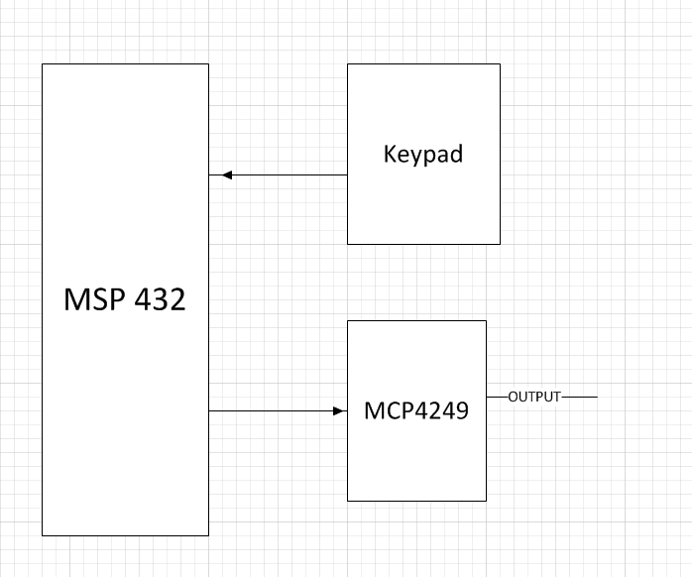

Figure – System Architecture Diagram

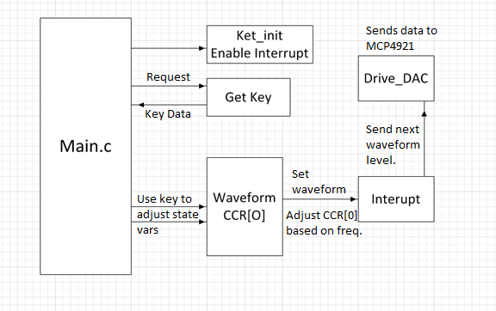

Figure 2 – System Software Diagram

# Component Design

All setting are default settings of MSP432P401R Launchpad running at 24 MHz with interrupts enabled.

* void main()
  + Set DCO to 24 MHz
  + Setup I/O pins
  + Enable interrupts
  + Get keypad state and adjust state
* void TA0_0_IRQHandler(void)
  + Sets waveform to next item in wave array
  + If in noise mode randomly generates a new noise value
  + Reset interrupt
* void Drive_DAC(void)
  + Provided function
  + Removed delay – did not affect wave and wasted cpu cycles.
  + Sends DAC a value to output
* delay() and delayMs(int)
  + Generate short delays that would be more expensive to set up a interrupt for.
* Key Get_key()
  + Polls the keypad.
* Key_init()
  + Sets pins for keypad as pull down inputs.

## Schematic

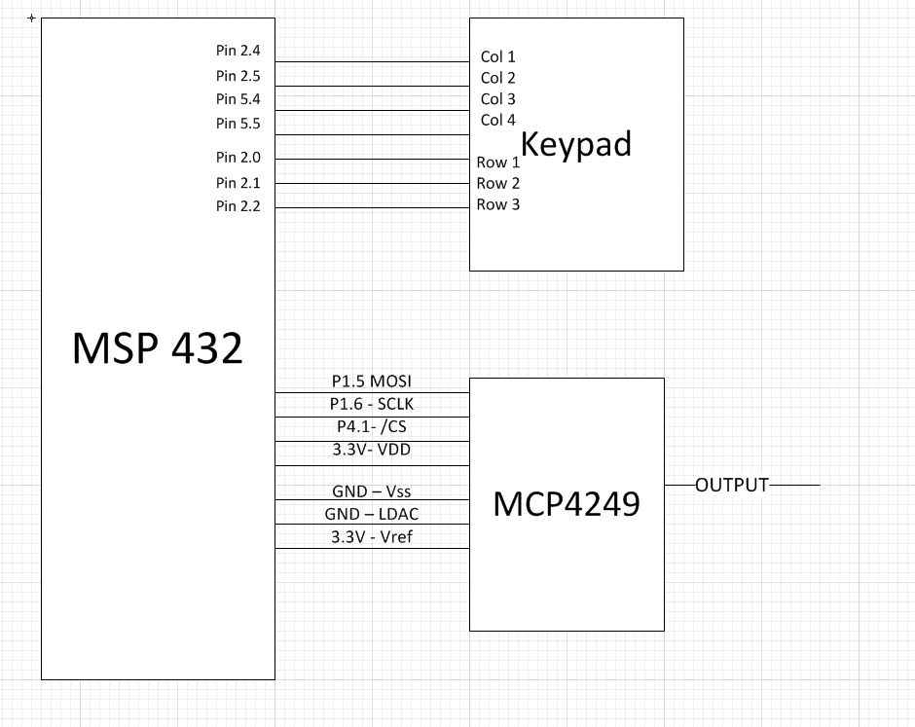

Figure 3 – Schematic Diagram

# Bill of Materials

|  |  |  |  |  |  |  |
| --- | --- | --- | --- | --- | --- | --- |
|  | Item # | Part # | Supplier | Quantity | Price Ea | Total Price $ |
| MSP432 Launchpad | 1 | MSP432P401R | Digikey | 1 | 13.03 |  |
| 7 pin, 12 button keypad | 2 |  | Digikey | 1 | 3.55 | 3.55 |
| Jumper cables | 3 | 0 | Amazon | 20 | .01 | .20 |
| 4921 SPI DAC | 4 | MCP4921 | Digikey | 1 | 1.69 | 1.69 |
| Breadboard | 5 | 352 | Pololu | 1 | 3.97 | 3.97 |
| Total |  |  |  |  |  | 9.41 |

# System Integration

The system was designed in two parts the keypad with its associated state machine, and the timer interrupt system that controlled the DAC. These parts interacted through one waveform variable pointing to the correct waveform, and the keypad state machine adjusting the CCR[0] values. The timer was chosen to operate in ‘UP’ mode, as the CCR[o] would not need to change on the interrupt that was and save a few cycles there, allowing greater resolution. A challenge approached when designing the system was the somewhat hard to predict outcome when the CCR[0] values were set too low and the CPU would be unable to fully exit the interrupt, as the next one was already queued up.

When setting up the built in parameters the scope was set up in such a way as to measure all the required values automatically so the values could quickly be adjusted to the proper numbers. See Figure 4 for an example of this.

The noise generation was another interesting challenge because it needed to be computationally cheap in order to keep the same resolution and not block out the keypad. A few of in house algorithms were tested before deciding on the linear congruential generator, a very fast generator used by many software solutions.

The pulse multiplier had some initial difficulties as the additional code threw off the timing for the 500 Hz interrupt and was locking the system. The code had to be refactored to be more optimized.

# Answers to Questions

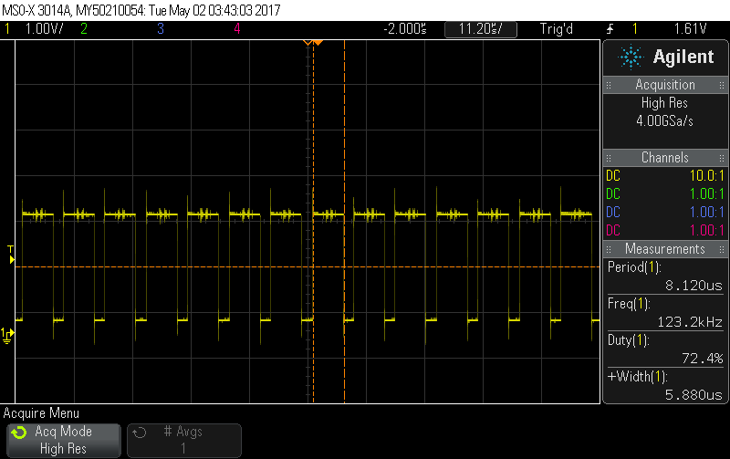

Figure 4 – 500 MHz wave interrupt timing.

Figure 4 shows how the 500 MHz wave was optimized to utilize the maximum amount of resolution by setting the CCR[0] value to just 47. Drive_DAC’s delay was removed to help achieve this, as well as any computation of the waves themselves. The MCP4921 Spec sheet lists a maximum operating frequency of 20 MHz, and because it takes more than 2 cycles per interrupt there is no effectively maximum bound for the MSP432 running at 24 MHz to send DAC level to the MCP4921

# Conclusion

In conclusion, a function waveform generator was design, built, and programming using the MSP432, MCP4921, and a keypad. This project stressed the importance of timing and for embedded systems using slower clocks than modern PC, every cycle can matter. Through careful setup of the interrupt function we were able to get 256 points of resolution per period. This results in a very smoothing looking waveform on the scope and comfortably could be used as a sine wave. The additional feature of pulsing allows systems to react to a wave then settle down internal circuits to close to initial conditions, a feature that could be very useful in industry. Noise simulation allows noise to be injected into a system, ensuring that the system can safely handle random data, even if that data is within safe voltage parameters. The design could be improved by shifting to 48 MHz, although that would introduce more complexities as this could operate faster than the DAC could shift between levels. Additionally looking at the spec sheet of the MCP4921 it described the LDAC pin and how it could be used to double buffer inputs. Further research may reveal applicable uses to the waveform generator, perhaps by sending multiple levels per interrupt and further increasing the resolution. Another advancement this project could benefit from would be the precomputation on the fly of the predefined levels for the waves. While this would increase the latency between each type of waveform, it would allow a greater flexibility in the properties of the waves.

In building this project it is recommended that one first gets a good understanding of how low one can set the CCR[0] values in order to maximize resolution. This means learning what pieces of code take more or less cycles to complete. In addition, take the spec sheets with a grain of salt, as sometimes one can go above or below the recommended parameters to get better results. This is seen in the code below when the Drive_DAC delay was removed. Finally, when adding additionally functionality, take into account the careful timing that the interrupts use and be wary that added code in the wrong location could throw that off.

# Appendices

## Referances

* CPE 329 - Project 2 – Function Genorator v0.02 - S2017
* [MSP432 - Technical Reference Manual File](http://www.ti.com/general/docs/litabsmultiplefilelist.tsp?literatureNumber=slau356f)
* [MCP4921 – Spec Sheet](http://ww1.microchip.com/downloads/en/devicedoc/21897b.pdf)
* Schematic created with: http://www.schematics.com/

## Code

### main.c

//*****************************************************************************

//

// MSP432 main.c - Project 2

//

//****************************************************************************

#include "msp.h"

#include "proj2.h"

#include <stdlib.h>

void Drive_DAC(unsigned int level);

volatile unsigned int TempDAC_Value = 0;

int *waveform;

int freq = FREQ_100_Hz; // in 100Hz

int fArr[6] = {470/2, 470/4, 470/6, 470/8, 470/10, 4700}; //CCRO values

int pulseMode;

int noise[256];

void main(void)

{

WDTCTL = WDTPW | WDTHOLD; // Stop watchdog timer

// DCO = 24 MHz, SMCLK and MCLK = DCO

CS->KEY = CS_KEY_VAL;

CS->CTL0 = 0;

CS->CTL0 = CS_CTL0_DCORSEL_4; // DCO = 24 MHz

CS->CTL1 = CS_CTL1_SELA_2 | CS_CTL1_SELS_3 | CS_CTL1_SELM_3;

CS->KEY = 0;

// Configure port bits for SPI

P4->DIR |= BIT1; // Will use BIT4 to activate /CE on the DAC

P1SEL0 |= BIT6 + BIT5; // Configure P1.6 and P1.5 for UCB0SIMO and UCB0CLK

P1SEL1 &= ~(BIT6 + BIT5); //

// SPI Setup

EUSCI_B0->CTLW0 |= EUSCI_B_CTLW0_SWRST; // Put eUSCI state machine in reset

EUSCI_B0->CTLW0 = EUSCI_B_CTLW0_SWRST | // Remain eUSCI state machine in reset

EUSCI_B_CTLW0_MST | // Set as SPI master

EUSCI_B_CTLW0_SYNC | // Set as synchronous mode

EUSCI_B_CTLW0_CKPL | // Set clock polarity high

EUSCI_B_CTLW0_MSB; // MSB first

EUSCI_B0->CTLW0 |= EUSCI_B_CTLW0_SSEL__SMCLK; // SMCLK

EUSCI_B0->BRW = 0x01; // divide by 16, clock = fBRCLK/(UCBRx)

EUSCI_B0->CTLW0 &= ~EUSCI_B_CTLW0_SWRST; // Initialize USCI state machine, SPI

// now waiting for something to

// be placed in TXBUF

EUSCI_B0->IFG |= EUSCI_B_IFG_TXIFG; // Clear TXIFG flag

//setup interupt

TIMER_A0->CCTL[0] = TIMER_A_CCTLN_CCIE; // TACCR0 interrupt enabled

TIMER_A0->CCR[0] = 470;

TIMER_A0->CTL = TIMER_A_CTL_SSEL__SMCLK | // SMCLK, continuous mode

TIMER_A_CTL_MC__UP |

TIMER_A_CTL_ID__4;

//SCB->SCR |= SCB_SCR_SLEEPONEXIT_Msk; // Enable sleep on exit from ISR

// Enable global interrupt

__enable_irq();

NVIC->ISER[0] = 1 << ((TA0_0_IRQn) & 31);

P6->DIR |= BIT0;

waveform = duty[3];

freq = FREQ_100_Hz;

TIMER_A0->CCR[0] = fArr[freq];

Key key = NONE;

Key_init();

int dutyNum = 4;

while (1) {

while (key != NONE) key = Get_key();

while (key == NONE) key = Get_key();

switch (key) {

case K1:

freq--;

if (freq < FREQ_100_Hz) freq = FREQ_100_Hz;

if (waveform == noise) freq = FREQ_100_Hz;

TIMER_A0->CCR[0] = fArr[freq];

break;

case K2:

freq = FREQ_300_Hz;

if (waveform == noise) freq = FREQ_100_Hz;

TIMER_A0->CCR[0] = fArr[freq];

break;

case K3:

freq++;

if (freq > FREQ_500_Hz) {

freq = FREQ_500_Hz;

}

if (waveform == noise) freq = FREQ_100_Hz;

TIMER_A0->CCR[0] = fArr[freq];

break;

case K4:

pulseMode = 0;

break;

case K5:

TIMER_A0->CCR[0] = fArr[0];

waveform = noise;

break;

case K6:

if (waveform != noise)

pulseMode = (pulseMode + 1) % 10;

break;

case K7:

dutyNum = 4;

waveform = duty[4];

pulseMode = 0;

break;

case K8:

pulseMode = 0;

waveform = sin;

break;

case K9:

pulseMode = 0;

waveform = saw;

break;

case K_STAR:

if (waveform != saw && waveform != sin && waveform != noise)

{

dutyNum = dutyNum + 1;

if (dutyNum > 8) dutyNum = 8;

waveform = duty[dutyNum];

}

break;

case K0:

if (waveform != saw && waveform != sin && waveform != noise)

{

dutyNum = 4;

waveform = duty[4];

}

break;

case K_POUND:

if (waveform != saw && waveform != sin)

{

dutyNum = dutyNum - 1;

if (dutyNum < 0) dutyNum = 0;

waveform = duty[dutyNum];

}

break;

}

}

}

void TA0_0_IRQHandler(void) {

static char step = 0;

static int pulseWait = 0;

static int rand = 35;

//P6->OUT |= BIT0;

TIMER_A0->CCTL[0] &= ~TIMER_A_CCTLN_CCIFG;

if (waveform != noise) {

Drive_DAC(waveform[step]);

if (step == 0 && pulseWait < (256 * pulseMode)) {

pulseWait++;

} else {

step = step + 1;

pulseWait = 0;

}

} else {

//rand ^= rand << 2; //alt PRNG

//rand ^= rand >> 7;

//rand ^= rand << 5;

rand = (4321*rand + 420);

Drive_DAC(rand % 1919);

}

//P6->OUT &= ~BIT0;

}

void Drive_DAC(unsigned int level){

unsigned int DAC_Word = 0;

//int i;

DAC_Word = (0x1000) | (level & 0x0FFF); // 0x1000 sets DAC for Write

// to DAC, Gain = 2, /SHDN = 1

// and put 12-bit level value

// in low 12 bits.

P4->OUT &= ~BIT1; // Clear P4.1 (drive /CS low on DAC)

// Using a port output to do this for now

EUSCI_B0->TXBUF = (unsigned char) (DAC_Word >> 8); // Shift upper byte of DAC_Word

// 8-bits to right

while (!(EUSCI_B0->IFG & EUSCI_B_IFG_TXIFG)); // USCI_A0 TX buffer ready?

EUSCI_B0->TXBUF = (unsigned char) (DAC_Word & 0x00FF); // Transmit lower byte to DAC

while (!(EUSCI_B0->IFG & EUSCI_B_IFG_TXIFG)); // Poll the TX flag to wait for completion

//for(i = 200; i > 0; i--); // Delay 200 16 MHz SMCLK periods

//to ensure TX is complete by SIMO

P4->OUT |= BIT1; // Set P4.1 (drive /CS high on DAC)

return;

}

void delay(){}

void delayMs(int n) {

int i, j;

for (j = 0; j < n; j++)

for (i = 750; i > 0; i--); /* Delay */

}

Key Get_key(void) {

Key retMe = NONE;

P2->OUT = 0xF7;

//row 1

P2->DIR = 0x00;

P2->DIR |= 0xF0;

P2->OUT &= ~0x10;

delay();

unsigned char in = P2->IN & 0x07;

P2->OUT |=0x10;

if (in == 0x6)

retMe = K3;

if (in == 0x5)

retMe = K2;

if (in == 0x3)

retMe = K1;

if (retMe != NONE) return retMe;

// row 2

P2->OUT &= ~0x20;

delay();

in = P2->IN & 0x07;

P2->OUT |=0x20;

if (in == 0x6)

retMe = K6;

if (in == 0x5)

retMe = K5;

if (in == 0x3)

retMe = K4;

//row 3

P5->DIR = 0x00;

P5->DIR |= 0x10;

P5->OUT &= ~0x10;

delay();

in = P2->IN & 0x07;

P5->OUT |=0x10;

if (in == 0x6)

retMe = K9;

if (in == 0x5)

retMe = K8;

if (in == 0x3)

retMe = K7;

//row 4

P5->DIR = 0x00;

P5->DIR |= 0x20;

P5->OUT &= ~0x20;

delay();

in = P2->IN & 0x07;

P5->OUT |=0x20;

if (in == 0x6)

retMe = K_POUND;

if (in == 0x5)

retMe = K0;

if (in == 0x3)

retMe = K_STAR;

P2->OUT = 0xF7;

P2->DIR = 0x00;

delayMs(1);

return retMe;

}

/* P2(0:2) is cols / input; P2(4:7) is rows/output */

void Key_init(void) {

P2->DIR = 0x00;

P2->REN = 0x70;

//P6->DIR &= ~BIT5;

//P6->REN |= BIT5;

}

### proj2.h

/*

* proj2.h

*

* Created on: Apr 28, 2017

* Author: kmrosent

*/

**#ifndef** PROJ2_H_

**#define** PROJ2_H_

**#define** RS 1 /* P4.0 mask */

**#define** RW 2 /* P4.1 mask */

**#define** EN 4 /* P4.2 mask */

**#define** CYCLES_PER_LOOP 11

**#define** SETUP_CYCLES 5

**#define** FREQ 32_KHz 32768

**#define** FREQ_1_5_MHz 1500000

**#define** FREQ_3_MHz 3000000

**#define** FREQ_6_MHz 6000000

**#define** FREQ_12_MHz 12000000

**#define** FREQ_24_MHz 24000000

**#define** FREQ_48_MHz 48000000

**#define** FREQ_100_Hz 0

**#define** FREQ_200_Hz 1

**#define** FREQ_300_Hz 2

**#define** FREQ_400_Hz 3

**#define** FREQ_500_Hz 4

**typedef** **unsigned** **long** ul;

**void** **delayMs**(**int** n);

**void** **delay_ms**(ul ms);

**void** **delay_ns**(ul ns);

**void** **Key_init**(**void**);

**typedef** **enum** { *K1* = 0, *K2*, *K3*, *K4*, *K5*, *K6*, *K7*, *K8*, *K9*, *K_STAR*, *K0*, *K_POUND*, *NONE* } Key;

Key **Get_key**(**void**);

//pregenorated waves

//sin wave precalulated with 128 steps

**int** sin[256] = {960,984,1007,1031,1054,1078,1101,1124,1147,1170,1193,1216,1239,

1261,1283,1305,1327,1349,1370,1392,1413,1433,1454,1474,1493,

1513,1532,1551,1569,1587,1605,1622,1639,1655,1671,1687,1702,

1717,1731,1745,1758,1771,1783,1795,1807,1817,1828,1838,1847,

1856,1864,1872,1879,1885,1891,1897,1902,1906,1910,1913,1915,

1917,1919,1920,1920,1920,1919,1917,1915,1913,1910,1906,1902,

1897,1891,1885,1879,1872,1864,1856,1847,1838,1828,1817,1807,

1795,1783,1771,1758,1745,1731,1717,1702,1687,1671,1655,1639,

1622,1605,1587,1569,1551,1532,1513,1493,1474,1454,1433,1413,

1392,1370,1349,1327,1305,1283,1261,1239,1216,1193,1170,1147,

1124,1101,1078,1054,1031,1007,984,960,936,913,889,866,842,

819,796,773,750,727,704,681,659,637,615,593,571,550,528,507,

487,466,446,427,407,388,369,351,333,315,298,281,265,249,233,

218,203,189,175,162,149,137,125,113,103,92,82,73,64,56,48,41,

35,29,23,18,14,10,7,5,3,1,0,0,0,1,3,5,7,10,14,18,23,29,35,41,

48,56,64,73,82,92,103,113,125,137,149,162,175,189,203,218,233,

249,265,281,298,315,333,351,369,388,407,427,446,466,487,507,

528,550,571,593,615,637,659,681,704,727,750,773,796,819,842,

866,889,913,936};

//saw wave precalulated with 128 steps

**int** saw[256] = {0,7,15,22,30,37,45,52,60,67,75,82,90,97,105,112,120,127,135,

142,150,157,165,172,180,187,195,202,210,217,225,232,240,247,

255,262,270,277,285,292,300,307,315,322,330,337,345,352,360,

367,375,382,390,397,405,412,420,427,435,442,450,457,465,472,

480,487,495,502,510,517,525,532,540,547,555,562,570,577,585,

592,600,607,615,622,630,637,645,652,660,667,675,682,690,697,

705,712,720,727,735,742,750,757,765,772,780,787,795,802,810,

817,825,832,840,847,855,862,870,877,885,892,900,907,915,922,

930,937,945,952,960,967,974,982,989,997,1004,1012,1019,1027,

1034,1042,1049,1057,1064,1072,1079,1087,1094,1102,1109,1117,

1124,1132,1139,1147,1154,1162,1169,1177,1184,1192,1199,1207,

1214,1222,1229,1237,1244,1252,1259,1267,1274,1282,1289,1297,

1304,1312,1319,1327,1334,1342,1349,1357,1364,1372,1379,1387,

1394,1402,1409,1417,1424,1432,1439,1447,1454,1462,1469,1477,

1484,1492,1499,1507,1514,1522,1529,1537,1544,1552,1559,1567,

1574,1582,1589,1597,1604,1612,1619,1627,1634,1642,1649,1657,

1664,1672,1679,1687,1694,1702,1709,1717,1724,1732,1739,1747,

1754,1762,1769,1777,1784,1792,1799,1807,1814,1822,1829,1837,

1844,1852,1859,1867,1874,1882,1889,1897,1904,1912};

//pregen'd duty cycles

**int** duty[9][256] = {

{0,0,0,0,0,0,0,0,0,0,0,0,0,0,0,0,0,0,0,0,0,0,0,0,0,0,1919,1919,1919,1919,1919,

1919,1919,1919,1919,1919,1919,1919,1919,1919,1919,1919,1919,1919,1919,1919,

1919,1919,1919,1919,1919,1919,1919,1919,1919,1919,1919,1919,1919,1919,1919,

1919,1919,1919,1919,1919,1919,1919,1919,1919,1919,1919,1919,1919,1919,1919,

1919,1919,1919,1919,1919,1919,1919,1919,1919,1919,1919,1919,1919,1919,1919,

1919,1919,1919,1919,1919,1919,1919,1919,1919,1919,1919,1919,1919,1919,1919,

1919,1919,1919,1919,1919,1919,1919,1919,1919,1919,1919,1919,1919,1919,1919,

1919,1919,1919,1919,1919,1919,1919,1919,1919,1919,1919,1919,1919,1919,1919,

1919,1919,1919,1919,1919,1919,1919,1919,1919,1919,1919,1919,1919,1919,1919,

1919,1919,1919,1919,1919,1919,1919,1919,1919,1919,1919,1919,1919,1919,1919,

1919,1919,1919,1919,1919,1919,1919,1919,1919,1919,1919,1919,1919,1919,1919,

1919,1919,1919,1919,1919,1919,1919,1919,1919,1919,1919,1919,1919,1919,1919,

1919,1919,1919,1919,1919,1919,1919,1919,1919,1919,1919,1919,1919,1919,1919,

1919,1919,1919,1919,1919,1919,1919,1919,1919,1919,1919,1919,1919,1919,1919,

1919,1919,1919,1919,1919,1919,1919,1919,1919,1919,1919,1919,1919,1919,1919,

1919,1919,1919,1919,1919,1919,1919,1919,1919,1919,1919,1919,1919,1919,1919},

{0,0,0,0,0,0,0,0,0,0,0,0,0,0,0,0,0,0,0,0,0,0,0,0,0,0,0,0,0,0,0,0,0,0,0,0,0,0,

0,0,0,0,0,0,0,0,0,0,0,0,0,0,1919,1919,1919,1919,1919,1919,1919,1919,1919,

1919,1919,1919,1919,1919,1919,1919,1919,1919,1919,1919,1919,1919,1919,1919,

1919,1919,1919,1919,1919,1919,1919,1919,1919,1919,1919,1919,1919,1919,1919,

1919,1919,1919,1919,1919,1919,1919,1919,1919,1919,1919,1919,1919,1919,1919,

1919,1919,1919,1919,1919,1919,1919,1919,1919,1919,1919,1919,1919,1919,1919,

1919,1919,1919,1919,1919,1919,1919,1919,1919,1919,1919,1919,1919,1919,1919,

1919,1919,1919,1919,1919,1919,1919,1919,1919,1919,1919,1919,1919,1919,1919,

1919,1919,1919,1919,1919,1919,1919,1919,1919,1919,1919,1919,1919,1919,1919,

1919,1919,1919,1919,1919,1919,1919,1919,1919,1919,1919,1919,1919,1919,1919,

1919,1919,1919,1919,1919,1919,1919,1919,1919,1919,1919,1919,1919,1919,1919,

1919,1919,1919,1919,1919,1919,1919,1919,1919,1919,1919,1919,1919,1919,1919,

1919,1919,1919,1919,1919,1919,1919,1919,1919,1919,1919,1919,1919,1919,1919,

1919,1919,1919,1919,1919,1919,1919,1919,1919,1919,1919,1919,1919,1919,1919,

1919,1919,1919,1919,1919,1919,1919,1919,1919,1919,1919,1919,1919,1919,1919},

{0,0,0,0,0,0,0,0,0,0,0,0,0,0,0,0,0,0,0,0,0,0,0,0,0,0,0,0,0,0,0,0,0,0,0,0,0,0,

0,0,0,0,0,0,0,0,0,0,0,0,0,0,0,0,0,0,0,0,0,0,0,0,0,0,0,0,0,0,0,0,0,0,0,0,0,0,

0,1919,1919,1919,1919,1919,1919,1919,1919,1919,1919,1919,1919,1919,1919,1919,

1919,1919,1919,1919,1919,1919,1919,1919,1919,1919,1919,1919,1919,1919,1919,

1919,1919,1919,1919,1919,1919,1919,1919,1919,1919,1919,1919,1919,1919,1919,

1919,1919,1919,1919,1919,1919,1919,1919,1919,1919,1919,1919,1919,1919,1919,

1919,1919,1919,1919,1919,1919,1919,1919,1919,1919,1919,1919,1919,1919,1919,

1919,1919,1919,1919,1919,1919,1919,1919,1919,1919,1919,1919,1919,1919,1919,

1919,1919,1919,1919,1919,1919,1919,1919,1919,1919,1919,1919,1919,1919,1919,

1919,1919,1919,1919,1919,1919,1919,1919,1919,1919,1919,1919,1919,1919,1919,

1919,1919,1919,1919,1919,1919,1919,1919,1919,1919,1919,1919,1919,1919,1919,

1919,1919,1919,1919,1919,1919,1919,1919,1919,1919,1919,1919,1919,1919,1919,

1919,1919,1919,1919,1919,1919,1919,1919,1919,1919,1919,1919,1919,1919,1919,

1919,1919,1919,1919,1919,1919,1919,1919,1919,1919,1919,1919,1919,1919 },

{0,0,0,0,0,0,0,0,0,0,0,0,0,0,0,0,0,0,0,0,0,0,0,0,0,0,0,0,0,0,0,0,0,0,0,0,0,0,

0,0,0,0,0,0,0,0,0,0,0,0,0,0,0,0,0,0,0,0,0,0,0,0,0,0,0,0,0,0,0,0,0,0,0,0,0,0,

0,0,0,0,0,0,0,0,0,0,0,0,0,0,0,0,0,0,0,0,0,0,0,0,0,0,0,1919,1919,1919,1919,

1919,1919,1919,1919,1919,1919,1919,1919,1919,1919,1919,1919,1919,1919,1919,

1919,1919,1919,1919,1919,1919,1919,1919,1919,1919,1919,1919,1919,1919,1919,

1919,1919,1919,1919,1919,1919,1919,1919,1919,1919,1919,1919,1919,1919,1919,

1919,1919,1919,1919,1919,1919,1919,1919,1919,1919,1919,1919,1919,1919,1919,

1919,1919,1919,1919,1919,1919,1919,1919,1919,1919,1919,1919,1919,1919,1919,

1919,1919,1919,1919,1919,1919,1919,1919,1919,1919,1919,1919,1919,1919,1919,

1919,1919,1919,1919,1919,1919,1919,1919,1919,1919,1919,1919,1919,1919,1919,

1919,1919,1919,1919,1919,1919,1919,1919,1919,1919,1919,1919,1919,1919,1919,

1919,1919,1919,1919,1919,1919,1919,1919,1919,1919,1919,1919,1919,1919,1919,

1919,1919,1919,1919,1919,1919,1919,1919,1919,1919,1919,1919,1919,1919},

{0,0,0,0,0,0,0,0,0,0,0,0,0,0,0,0,0,0,0,0,0,0,0,0,0,0,0,0,0,0,0,0,0,0,0,0,0,0,

0,0,0,0,0,0,0,0,0,0,0,0,0,0,0,0,0,0,0,0,0,0,0,0,0,0,0,0,0,0,0,0,0,0,0,0,0,0,

0,0,0,0,0,0,0,0,0,0,0,0,0,0,0,0,0,0,0,0,0,0,0,0,0,0,0,0,0,0,0,0,0,0,0,0,0,0,

0,0,0,0,0,0,0,0,0,0,0,0,0,0,1919,1919,1919,1919,1919,1919,1919,1919,1919,

1919,1919,1919,1919,1919,1919,1919,1919,1919,1919,1919,1919,1919,1919,1919,

1919,1919,1919,1919,1919,1919,1919,1919,1919,1919,1919,1919,1919,1919,1919,

1919,1919,1919,1919,1919,1919,1919,1919,1919,1919,1919,1919,1919,1919,1919,

1919,1919,1919,1919,1919,1919,1919,1919,1919,1919,1919,1919,1919,1919,1919,

1919,1919,1919,1919,1919,1919,1919,1919,1919,1919,1919,1919,1919,1919,1919,

1919,1919,1919,1919,1919,1919,1919,1919,1919,1919,1919,1919,1919,1919,1919,

1919,1919,1919,1919,1919,1919,1919,1919,1919,1919,1919,1919,1919,1919,1919,

1919,1919,1919,1919,1919,1919,1919,1919,1919,1919,1919,1919,1919,1919},

{0,0,0,0,0,0,0,0,0,0,0,0,0,0,0,0,0,0,0,0,0,0,0,0,0,0,0,0,0,0,0,0,0,0,0,0,0,0,

0,0,0,0,0,0,0,0,0,0,0,0,0,0,0,0,0,0,0,0,0,0,0,0,0,0,0,0,0,0,0,0,0,0,0,0,0,0,

0,0,0,0,0,0,0,0,0,0,0,0,0,0,0,0,0,0,0,0,0,0,0,0,0,0,0,0,0,0,0,0,0,0,0,0,0,0,

0,0,0,0,0,0,0,0,0,0,0,0,0,0,0,0,0,0,0,0,0,0,0,0,0,0,0,0,0,0,0,0,0,0,0,0,0,0,

0,0,1919,1919,1919,1919,1919,1919,1919,1919,1919,1919,1919,1919,1919,1919,

1919,1919,1919,1919,1919,1919,1919,1919,1919,1919,1919,1919,1919,1919,1919,

1919,1919,1919,1919,1919,1919,1919,1919,1919,1919,1919,1919,1919,1919,1919,

1919,1919,1919,1919,1919,1919,1919,1919,1919,1919,1919,1919,1919,1919,1919,

1919,1919,1919,1919,1919,1919,1919,1919,1919,1919,1919,1919,1919,1919,1919,

1919,1919,1919,1919,1919,1919,1919,1919,1919,1919,1919,1919,1919,1919,1919,

1919,1919,1919,1919,1919,1919,1919,1919,1919,1919,1919,1919,1919},

{0,0,0,0,0,0,0,0,0,0,0,0,0,0,0,0,0,0,0,0,0,0,0,0,0,0,0,0,0,0,0,0,0,0,0,0,0,

0,0,0,0,0,0,0,0,0,0,0,0,0,0,0,0,0,0,0,0,0,0,0,0,0,0,0,0,0,0,0,0,0,0,0,0,0,

0,0,0,0,0,0,0,0,0,0,0,0,0,0,0,0,0,0,0,0,0,0,0,0,0,0,0,0,0,0,0,0,0,0,0,0,0,

0,0,0,0,0,0,0,0,0,0,0,0,0,0,0,0,0,0,0,0,0,0,0,0,0,0,0,0,0,0,0,0,0,0,0,0,0,

0,0,0,0,0,0,0,0,0,0,0,0,0,0,0,0,0,0,0,0,0,0,0,0,0,0,0,0,0,0,0,0,1919,1919,

1919,1919,1919,1919,1919,1919,1919,1919,1919,1919,1919,1919,1919,1919,1919,

1919,1919,1919,1919,1919,1919,1919,1919,1919,1919,1919,1919,1919,1919,1919,

1919,1919,1919,1919,1919,1919,1919,1919,1919,1919,1919,1919,1919,1919,1919,

1919,1919,1919,1919,1919,1919,1919,1919,1919,1919,1919,1919,1919,1919,1919,

1919,1919,1919,1919,1919,1919,1919,1919,1919,1919,1919,1919,1919,1919},

{0,0,0,0,0,0,0,0,0,0,0,0,0,0,0,0,0,0,0,0,0,0,0,0,0,0,0,0,0,0,0,0,0,0,0,0,0,0,

0,0,0,0,0,0,0,0,0,0,0,0,0,0,0,0,0,0,0,0,0,0,0,0,0,0,0,0,0,0,0,0,0,0,0,0,0,0,

0,0,0,0,0,0,0,0,0,0,0,0,0,0,0,0,0,0,0,0,0,0,0,0,0,0,0,0,0,0,0,0,0,0,0,0,0,0,

0,0,0,0,0,0,0,0,0,0,0,0,0,0,0,0,0,0,0,0,0,0,0,0,0,0,0,0,0,0,0,0,0,0,0,0,0,0,

0,0,0,0,0,0,0,0,0,0,0,0,0,0,0,0,0,0,0,0,0,0,0,0,0,0,0,0,0,0,0,0,0,0,0,0,0,0,

0,0,0,0,0,0,0,0,0,0,0,0,0,0,0,1919,1919,1919,1919,1919,1919,1919,1919,1919,

1919,1919,1919,1919,1919,1919,1919,1919,1919,1919,1919,1919,1919,1919,1919,

1919,1919,1919,1919,1919,1919,1919,1919,1919,1919,1919,1919,1919,1919,1919,

1919,1919,1919,1919,1919,1919,1919,1919,1919,1919,1919,1919},

{0,0,0,0,0,0,0,0,0,0,0,0,0,0,0,0,0,0,0,0,0,0,0,0,0,0,0,0,0,0,0,0,0,0,0,0,0,0,0,

0,0,0,0,0,0,0,0,0,0,0,0,0,0,0,0,0,0,0,0,0,0,0,0,0,0,0,0,0,0,0,0,0,0,0,0,0,0,0,

0,0,0,0,0,0,0,0,0,0,0,0,0,0,0,0,0,0,0,0,0,0,0,0,0,0,0,0,0,0,0,0,0,0,0,0,0,0,0,

0,0,0,0,0,0,0,0,0,0,0,0,0,0,0,0,0,0,0,0,0,0,0,0,0,0,0,0,0,0,0,0,0,0,0,0,0,0,0,

0,0,0,0,0,0,0,0,0,0,0,0,0,0,0,0,0,0,0,0,0,0,0,0,0,0,0,0,0,0,0,0,0,0,0,0,0,0,0,

0,0,0,0,0,0,0,0,0,0,0,0,0,0,0,0,0,0,0,0,0,0,0,0,0,0,0,0,0,0,0,0,0,0,0,0,1919,

1919,1919,1919,1919,1919,1919,1919,1919,1919,1919,1919,1919,1919,1919,1919,

1919,1919,1919,1919,1919,1919,1919,1919,1919}};

**#endif** /* PROJ2_H_ */